Melbourne Water is relining sections of the ageing North Yarra Main Sewer to enhance life and liveability in your area.
Sewer relining works from maintenance hole NYM115 to NYM112 are scheduled to commence in the week of Monday,
4 March 2024* and can take 2-3 weeks to complete.
What to expect
- Access trails will be closed for the duration of the works, with detours in place.
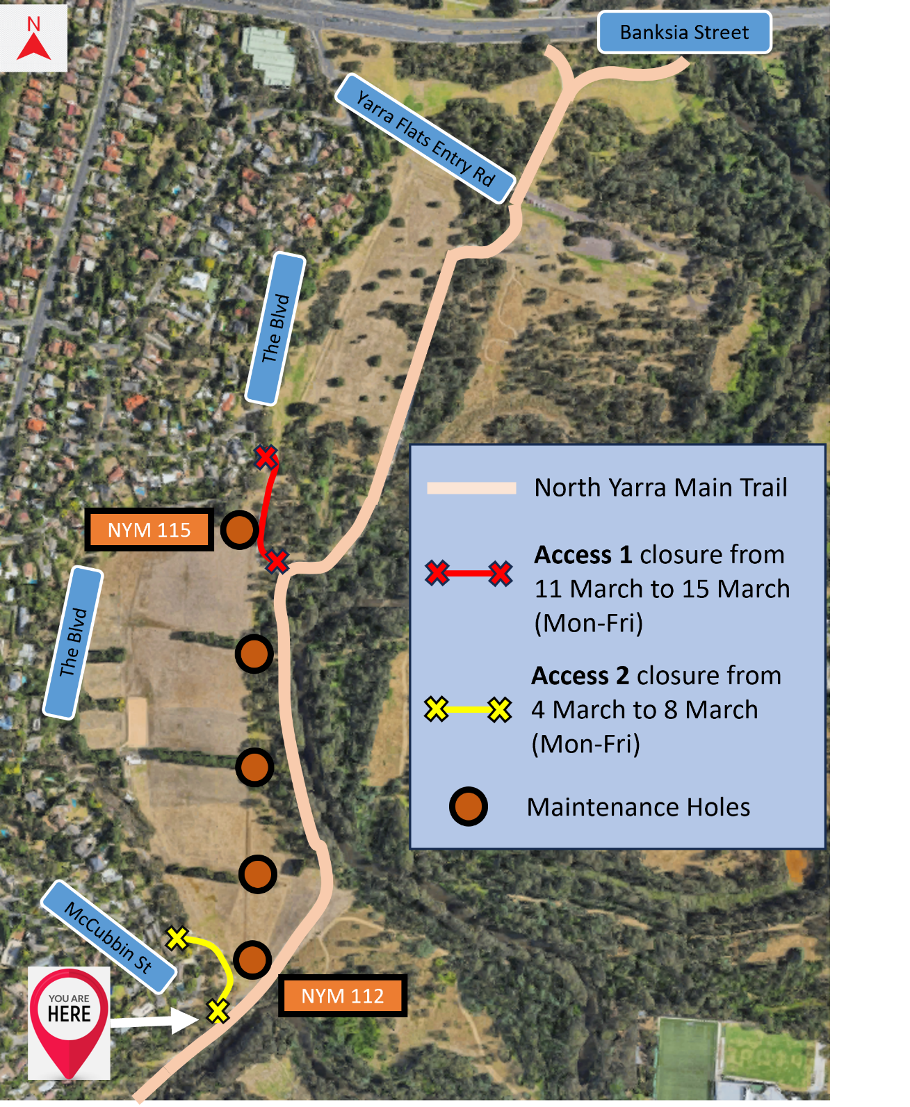
- We will only be closing one access trail at a time.

- Please plan ahead and allow extra time for detours.

Working Hours
Working hours are between 7am and 6pm, Monday to Friday*.

*These dates and times are indicative and subject to change with no prior notice due to weather conditions and fluctuating sewer flows.

